COVID-19 Time Series Analysis
United States | January 2020 – March 2023

Insight Generation, Forecasting & Policy Report

Course | Data Science & Analytics
Project | Project 3 — Time Series & Forecasting
Dataset | Johns Hopkins CSSE COVID-19 Data
Date Range | 22 January 2020 – 9 March 2023

1. Executive Summary
This report presents a comprehensive time series analysis of COVID-19 confirmed cases and deaths across US counties and states, using the Johns Hopkins University CSSE dataset covering 1,143 days from January 2020 through March 2023. The analysis addresses four core objectives: data pre-processing and descriptive analysis; statistical and deep-learning forecasting; identification of high-risk regions and peak fatality windows; and derivation of evidence-based policy recommendations.

Metric | Value
Total US Confirmed Cases | 103,802,702
Total US Deaths | 1,123,836
National Case Fatality Rate | 1.08%
Days Tracked | 1,143 (Jan 22 2020 – Mar 9 2023)
Counties Analysed | 3,342
ARIMA Model | ARIMA(2,0,1) — MAE: 9,959 | RMSE: 11,204
LSTM Model | 50-unit LSTM, 30-day window — MAE: 6,009 | RMSE: 8,133
Highest-Burden County | Los Angeles, California
Deadliest Period | December 2020 – January 2021

Key finding: The LSTM outperformed ARIMA on raw accuracy. However, ARIMA (2,0,1) provides interpretable, statistically grounded forecasts suitable for policy communication. Both models project a continued decline in daily new cases from the end of the dataset (March 2023), consistent with the late-pandemic wind-down trend.

2. Data & Methodology

2.1 Dataset Description
Two CSV files were provided by Johns Hopkins University CSSE: time_series_covid19_confirmed_US.csv and time_series_covid19_deaths_US.csv. Each file contains one row per county-level administrative unit, with columns for location identifiers followed by daily cumulative counts from 22 January 2020 through 9 March 2023.

2.2 Pre-processing Steps
- Read both CSV files and performed initial exploration using descriptive statistics and head () inspection.
- Dropped redundant identifier columns (UID, iso2, iso3, code3, FIPS, Lat, Long_), retaining only Combined_Key, Admin2, Province_State, Country_Region, and all 1,143 date columns.
- Identified 6 missing Admin2 values in each dataset and filled them with 'Unknown' to preserve the associated case data.
- Converted date columns to integers and validated consistency. 7,565 entries showed deaths > confirmed cases, attributed to known reporting lags in the raw data.
- Merged the two datasets on Combined_Key using an inner join, producing a dataset of 3,342 rows × 2,293 columns.

2.3 Analytical Approach
The analysis proceeded in four phases:
- Descriptive Analysis — national and state-level trend visualisation, heatmaps, case fatality rate, and choropleth mapping.
- Time Series Modelling — stationarity testing, ARIMA parameter selection via ACF/PACF, model training and evaluation, and LSTM implementation.
- Insight Generation — 30-day ARIMA forecasting per state, peak region identification, fatality window analysis, and external factor annotation.
- Policy Reporting — synthesis of findings into actionable recommendations.

3. Descriptive Analysis

3.1 National Trends
The charts below present the national cumulative and daily case/death trajectory for the United States across the full study period.

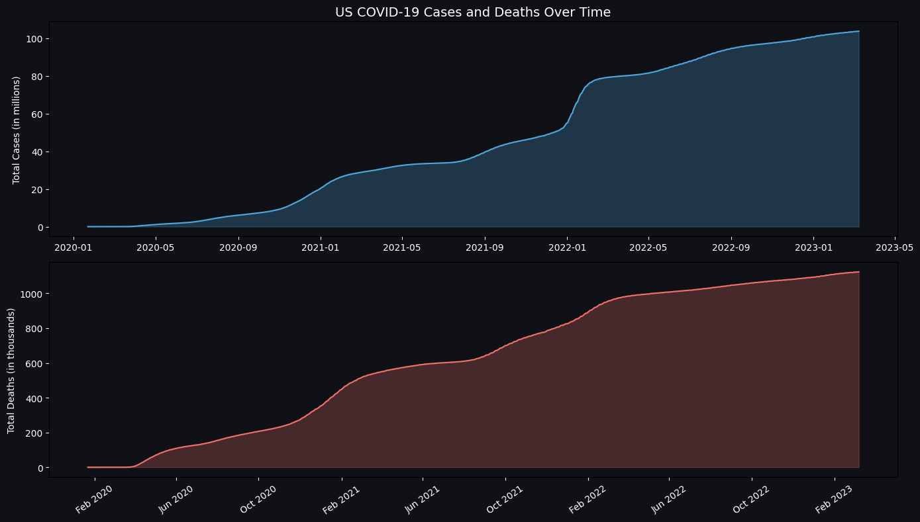
Figure 1 — US Cumulative COVID-19 Cases (blue) and Deaths (red) Over Time

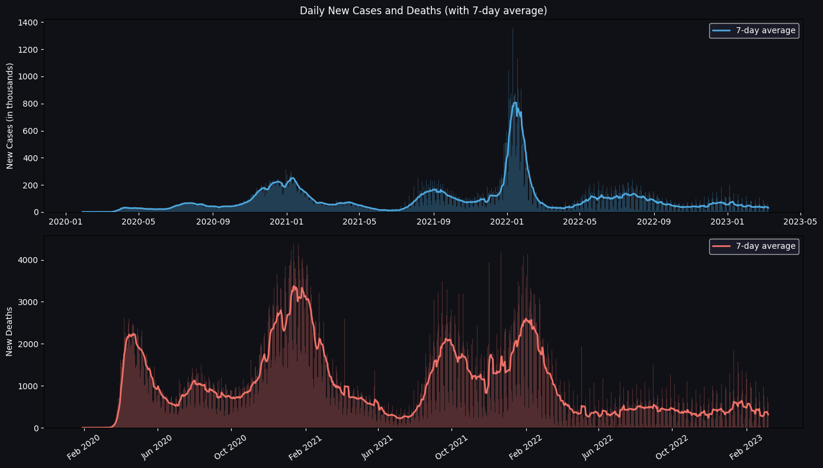
Figure 2 — US Daily New Cases and Deaths with 7-Day Rolling Average

Three distinct national surges are visible in Figure 2. The first major wave peaked in summer 2020. The deadliest wave occurred in winter 2020–21, driven probably by the Alpha variant and holiday gatherings. The third and largest surge by case volume occurred in December 2021 – February 2022, attributed to the highly transmissible Omicron variant, though with a lower-case fatality rate.

3.2 Regional Comparison — Top Counties and States
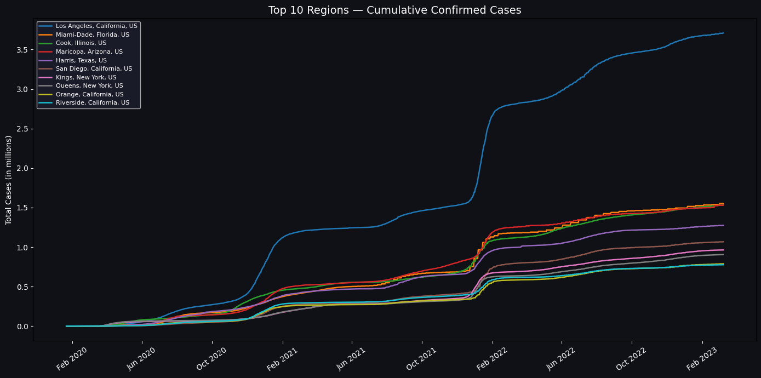
Figure 3 — Top 10 US Counties by Cumulative Confirmed Cases

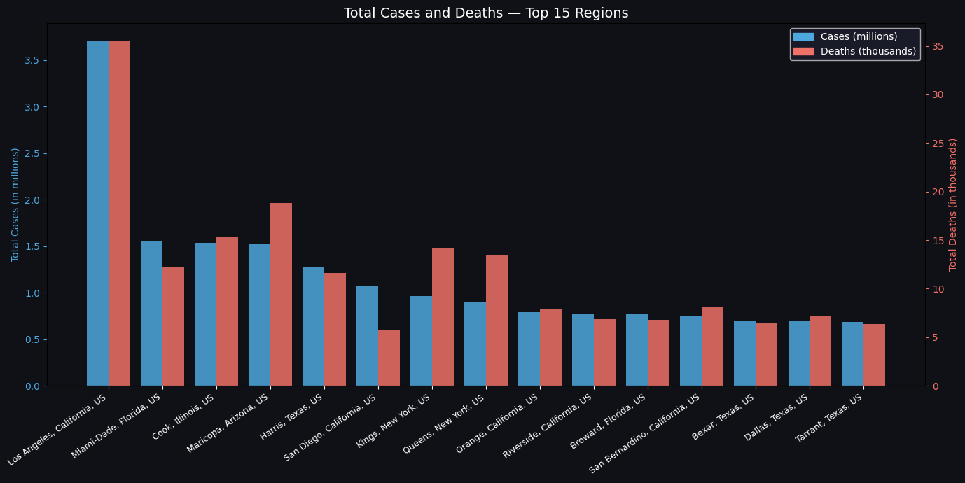
Figure 4 — Total Cases and Deaths for Top 15 Counties (Dual-Axis Bar Chart)

Los Angeles, Miami-Dade, and Cook County (Chicago) consistently rank as the highest-burden counties, reflecting the role of dense urban populations in driving transmission. Notably, Figure 4 shows that counties with the highest case counts do not always have the proportionally highest death counts, suggesting differences in demographics, healthcare capacity, and vaccination uptake.

3.3 Case Fatality Rate Analysis
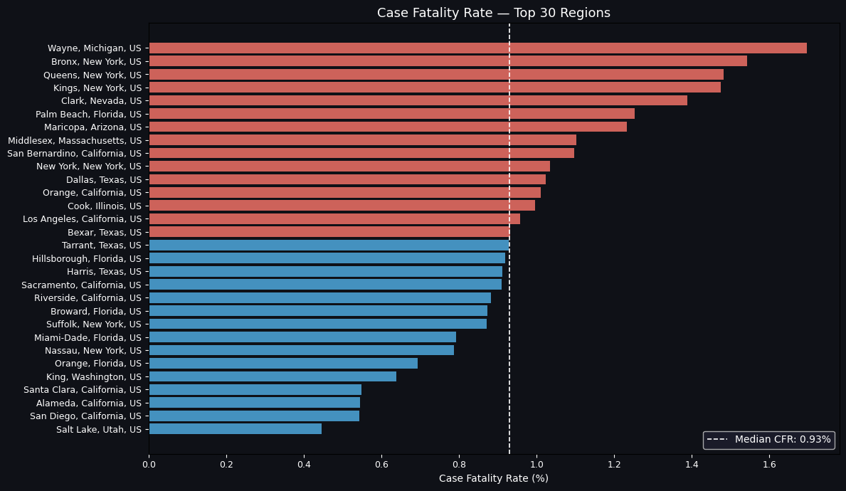
Figure 5 — Case Fatality Rate (CFR) for Top 30 Counties. Red = above median CFR. Median CFR: 0.93%
The median case fatality rate across the top 30 counties was 0.93%. Counties exceeding this threshold (shown in red) tend to be located in regions with older populations, earlier pandemic exposure before intensive care protocols were established, or lower healthcare access. This reinforces the importance of targeted resource allocation rather than uniform national responses.

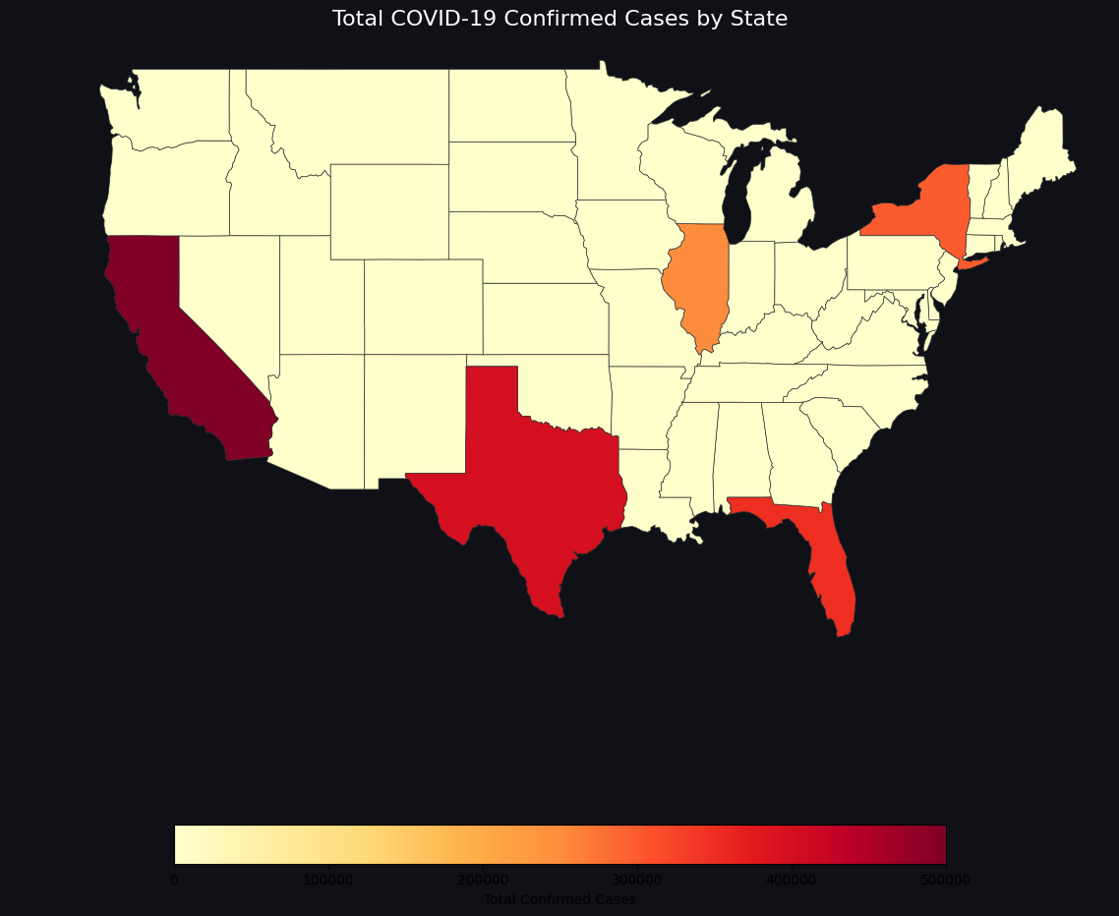
3.4 Geographic Distribution

Figure 6 — Choropleth Map: Total Confirmed Cases by US State

The choropleth map reveals strong geographic concentration of cases in populous coastal and Sun Belt states. California, Texas, Florida, and New York account for a disproportionate share of total national cases. This geographic clustering has direct implications for resource deployment and inter-state coordination policies.

3.5 Temporal Heatmaps
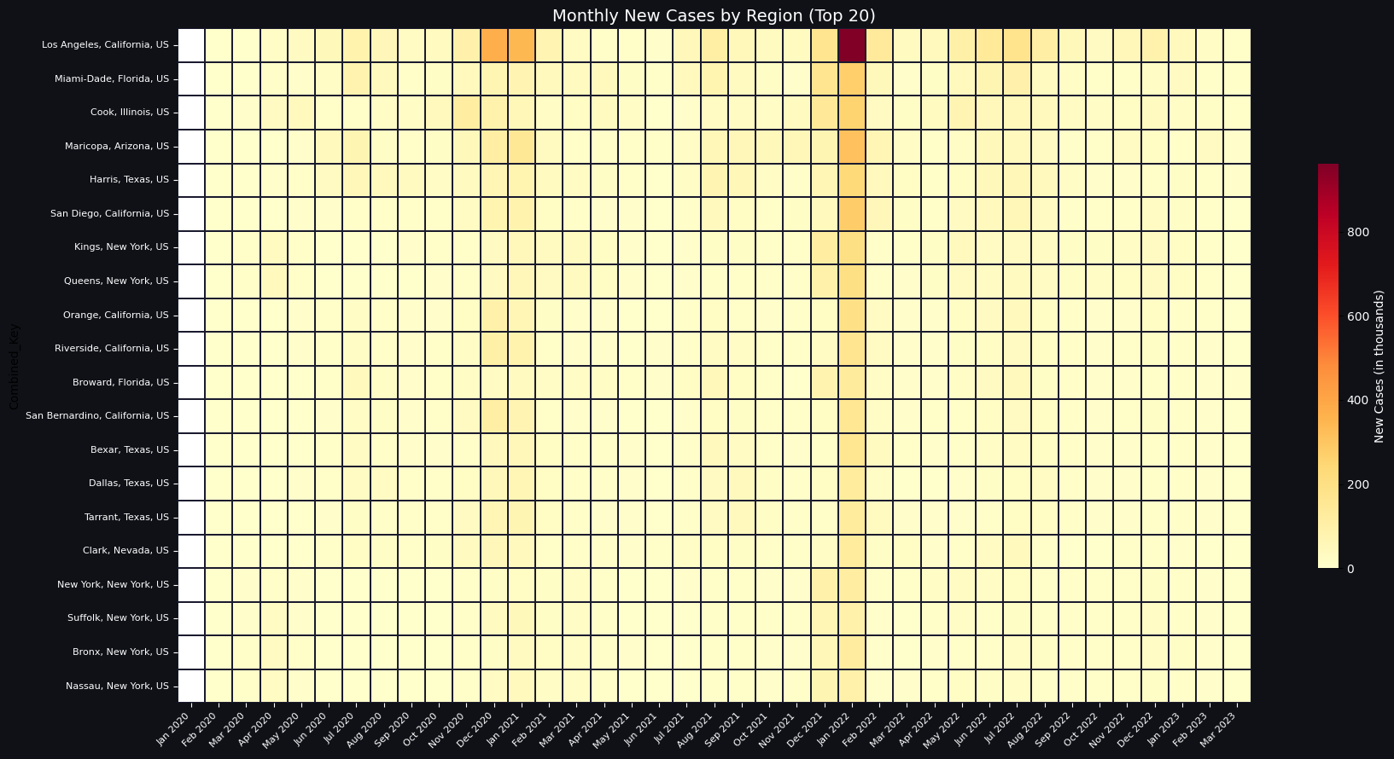
Figure 7 — Monthly New Cases Heatmap: Top 20 Counties (Yellow = Low, Red = High)

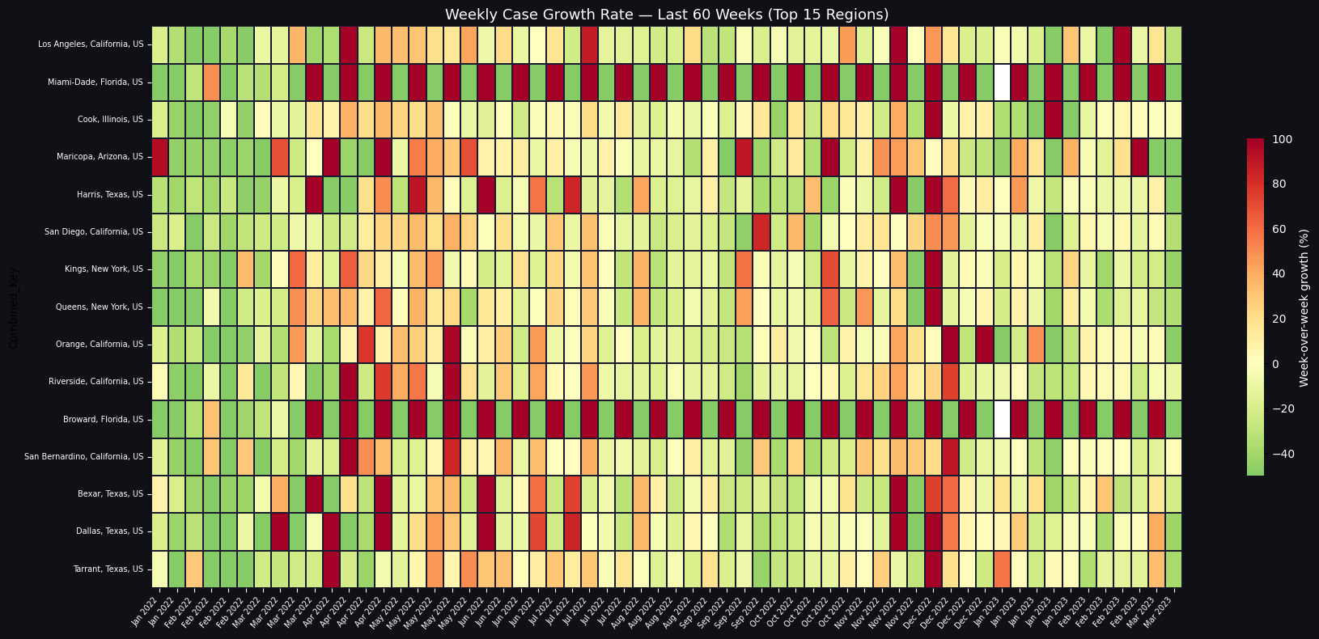
Figure 8 — Weekly Case Growth Rate Heatmap: Top 15 Counties (Red = Rapid Growth, Green = Declining)

Figure 7 confirms the winter 2021 Omicron surge as the single highest monthly case volume across nearly all top counties. Figure 8 reveals that growth rates were most volatile in 2020–21, with several counties experiencing week-over-week growth exceeding 100% during the initial outbreak and Alpha wave. By 2022, growth rates stabilised, reflecting the dampening effect of population immunity and vaccination.

4. State-Level Analysis: Five Focus States
Five high-burden states were selected for deeper analysis: California, Texas, Florida, New York, and Illinois. These states collectively represent the largest population centres and consistently led national case counts.

4.1 Cumulative Case and Death Trends
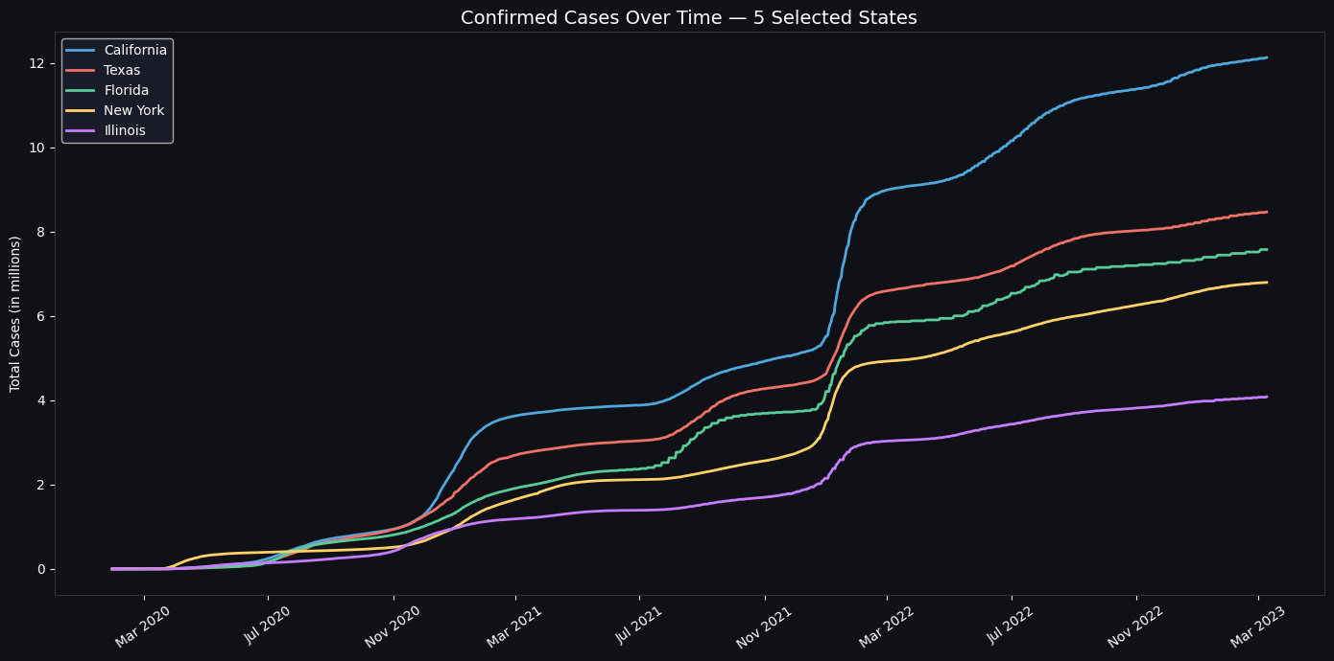
Figure 9 — Cumulative Confirmed Cases Over Time: 5 Selected States

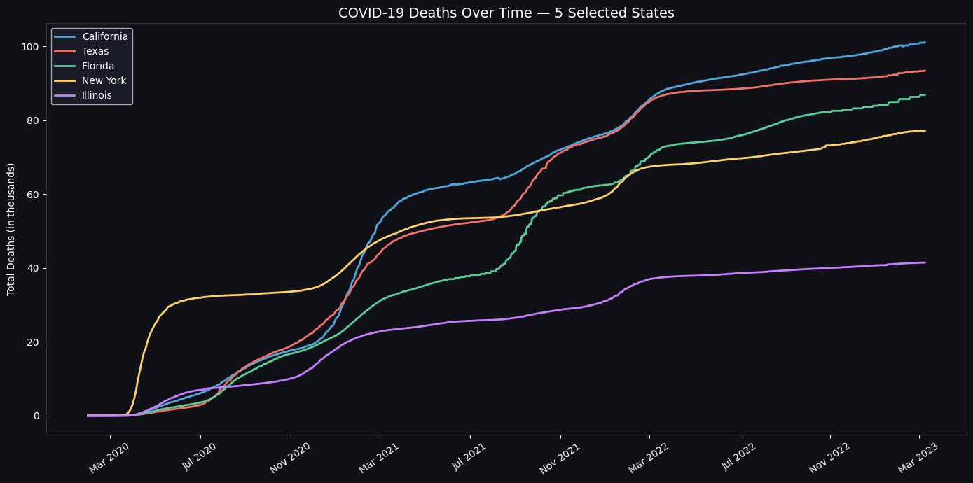
Figure 10 — Cumulative Deaths Over Time: 5 Selected States

California leads all five states in total confirmed cases, reaching approximately 12.1 million by March 2023. Texas and Florida follow closely. New York, despite being the hardest-hit early in the pandemic (March–April 2020), was ultimately surpassed in total case count due to the larger populations of California, Texas, and Florida.

4.2 Daily and Weekly New Cases
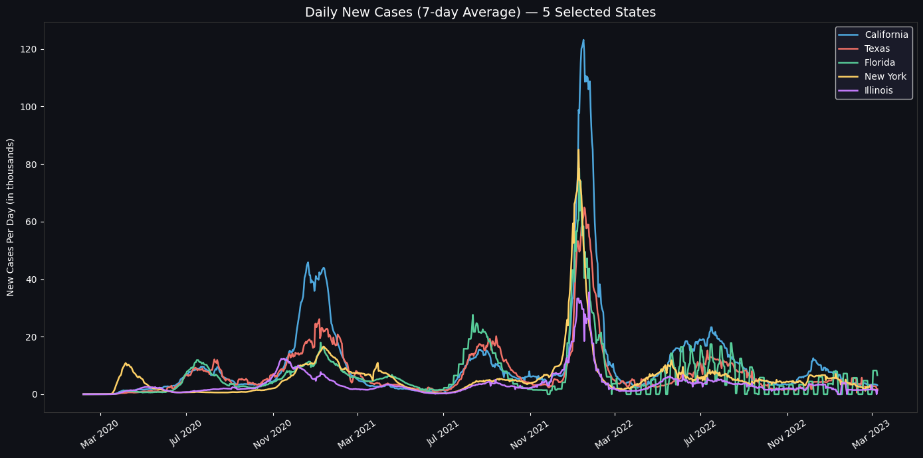
Figure 11 — Daily New Cases (7-Day Average): 5 Selected States

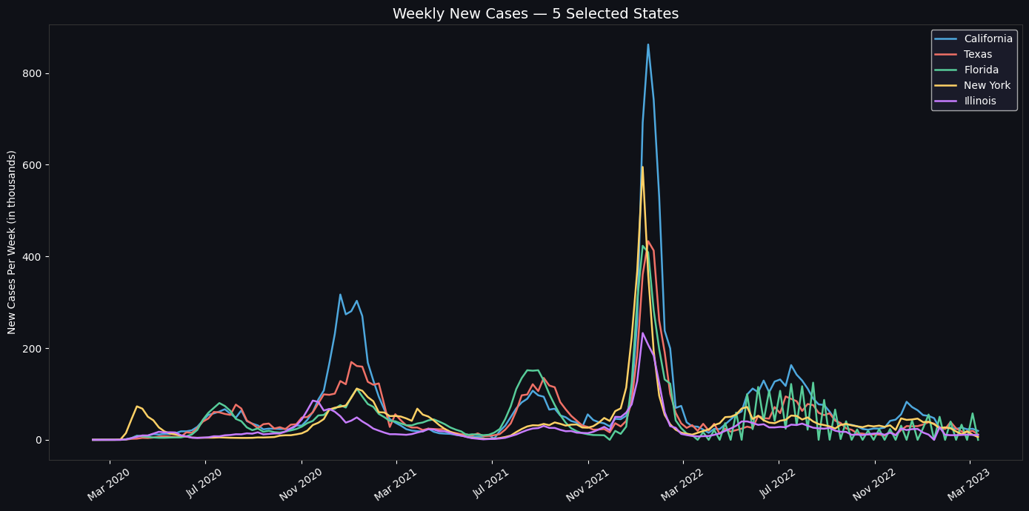
Figure 12 — Weekly New Cases: 5 Selected States

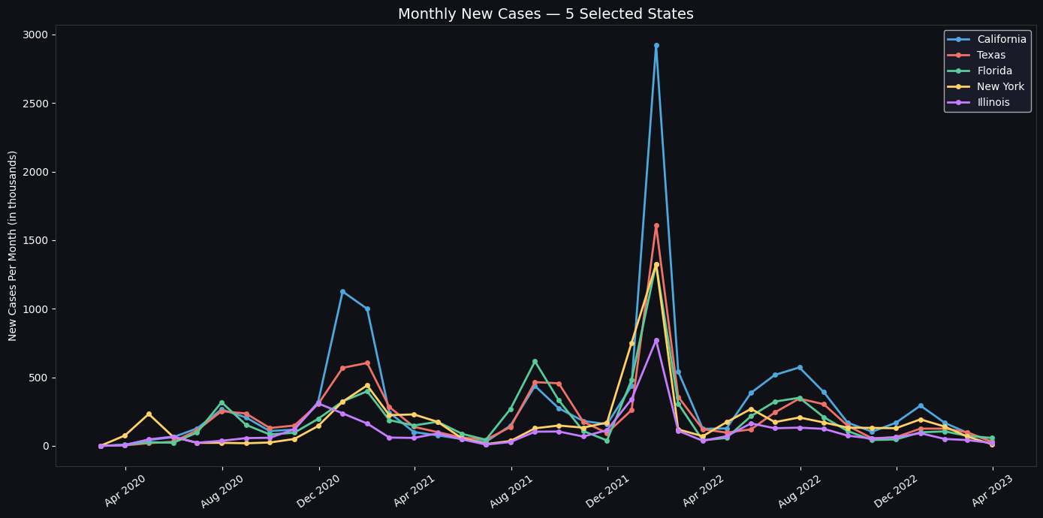
Figure 13 — Monthly New Cases: 5 Selected States

The daily 7-day average (Figure 11) clearly shows the Omicron surge in January 2022 as the dominant spike across all five states, dwarfing all prior waves in case volume. California's surge was particularly sharp. The monthly view (Figure 13) highlights that January 2022 was the single worst month for new cases in all five states simultaneously — an important finding for future pandemic preparedness planning.

5. Time Series Modelling

5.1 Stationarity Check — Augmented Dickey-Fuller Test
Before fitting an ARIMA model, the time series must be stationary (constant mean and variance over time). The ADF test was applied to California's daily new case series.

Metric | Value
ADF Statistic | -4.351
p-value | 0.000363 (< 0.001)
Conclusion | Series is stationary (p < 0.05) — no differencing required (d = 0)

The very low p-value confirms stationarity, meaning the series does not have a long-term trend or unit root. This is expected for daily new cases (as opposed to cumulative totals), since it fluctuates around a relatively stable mean after the initial outbreak phase.

5.2 ACF and PACF Analysis
Autocorrelation Function (ACF) and Partial Autocorrelation Function (PACF) plots were used to identify the ARIMA order parameters p (AR order) and q (MA order).

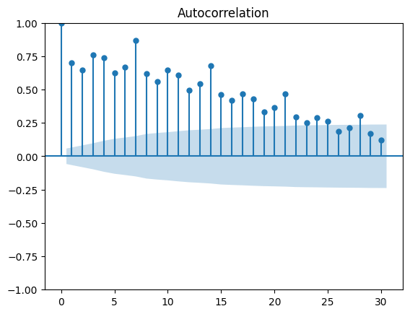
Figure 14 — ACF Plot: Significant autocorrelation at lag 1, gradual decay → q = 1

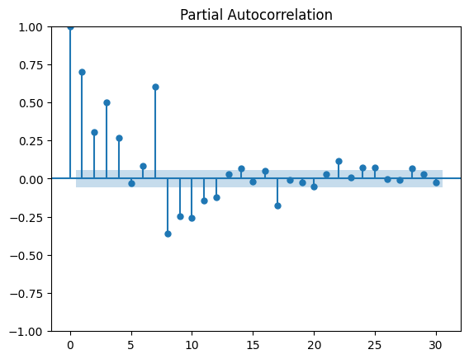
Figure 15 — PACF Plot: Sharp cut-off after lag 2 → p = 2

Parameter selection rationale: The PACF shows strong spikes at lags 1 and 2, dropping off sharply thereafter, indicating an autoregressive component of p = 2. The ACF shows significant correlation at lag 1 with gradual decay, suggesting a moving average component of q = 1 or 2. Combined with d = 0 (stationarity confirmed), models ARIMA (2,0,1) and ARIMA (2,0,2) were evaluated.

5.3 ARIMA Model Training and Evaluation

Model | MAE | RMSE | Status
ARIMA (2,0,1) | 9,959 | 11,204 | Selected
ARIMA (2,0,2) | 10,058 | 11,298 | Not selected

ARIMA (2,0,1) was selected as the final model based on marginally lower MAE and RMSE. The difference is small but consistent. MAPE was not used as a primary metric because California's daily case data contains zero values (days with no reported or corrected cases), causing division-by-zero errors that produce infinite MAPE values.

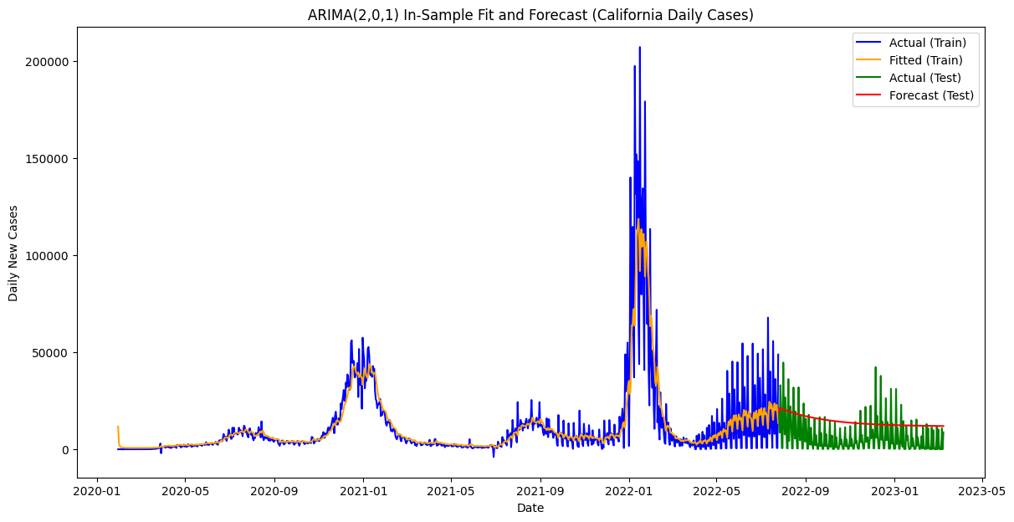
Figure 16 — ARIMA (2,0,1): In-Sample Fit (Train) and Out-of-Sample Forecast (Test) vs Actual

Figure 16 shows the model captures the overall trend well during the training period (blue/orange overlap). In the test period (green vs red), the forecast correctly predicts the downward trajectory, though it smooths out the sharp weekly reporting spikes that are common in COVID-19 data.

5.4 LSTM Model
A Long Short-Term Memory (LSTM) neural network was implemented as an alternative to ARIMA, capable of learning non-linear temporal patterns.

Parameter | Value
Sequence Length | 30 days
Architecture | 1 LSTM layer (50 units) + Dense(1)
Training Epochs | 20
Batch Size | 32
Train/Test Split | 80% / 20%
MAE | 6,009
RMSE | 8,133

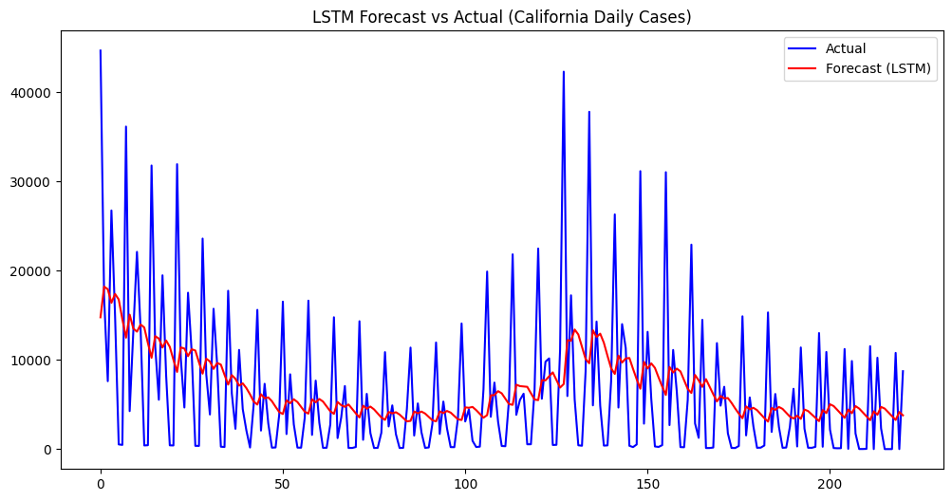
Figure 17 — LSTM Forecast vs Actual (California Daily New Cases, Test Period)

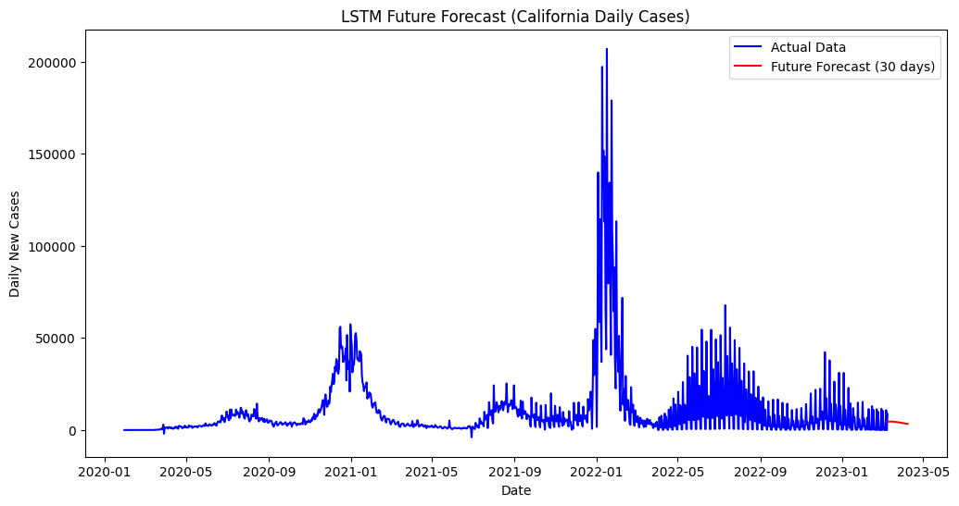
Figure 18 — LSTM 30-Day Future Forecast Beyond Dataset End

The LSTM achieved lower MAE (6,009 vs 9,959) and RMSE (8,133 vs 11,204) than ARIMA, indicating superior short-term accuracy. The LSTM's ability to learn from 30-day sequences allows it to capture lagged wave patterns that ARIMA's simple AR/MA structure cannot represent. However, the LSTM is a complex model— its outputs are harder to interpret and communicate to non-technical stakeholders.

Metric | ARIMA (2,0,1) | LSTM | Notes
MAE | 9,959 | 6,009 | LSTM better by 40%
RMSE | 11,204 | 8,133 | LSTM better by 27%
Interpretability | High | Low | ARIMA preferred for policy
Training Speed | Seconds | Minutes | ARIMA faster
Handles non-linearity | No | Yes | LSTM advantage
Confidence intervals | Yes | No | ARIMA advantage

6. Insight Generation

6.1 Forecasted Case Trajectories per State
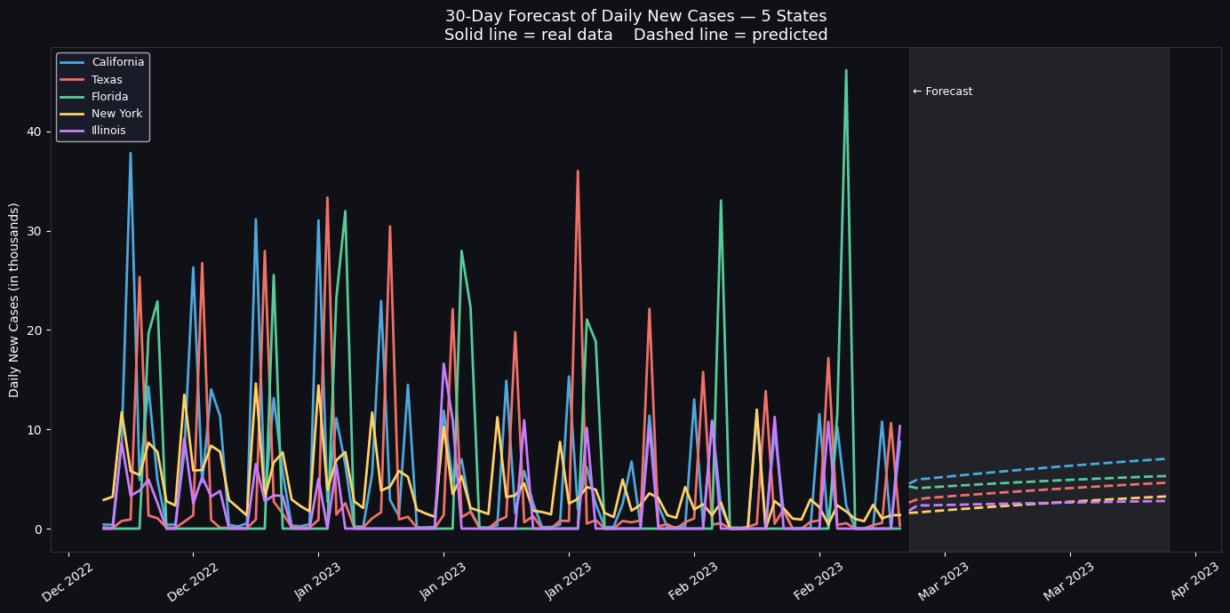
ARIMA (2,0,1) was applied to each of the five focus states, trained on the full available series, and used to forecast 30 days beyond the dataset end . The table below summarises predicted trajectories:

Figure 19 — 30-Day ARIMA Forecast — Daily New Cases per State (Solid = actual | Dashed = predicted

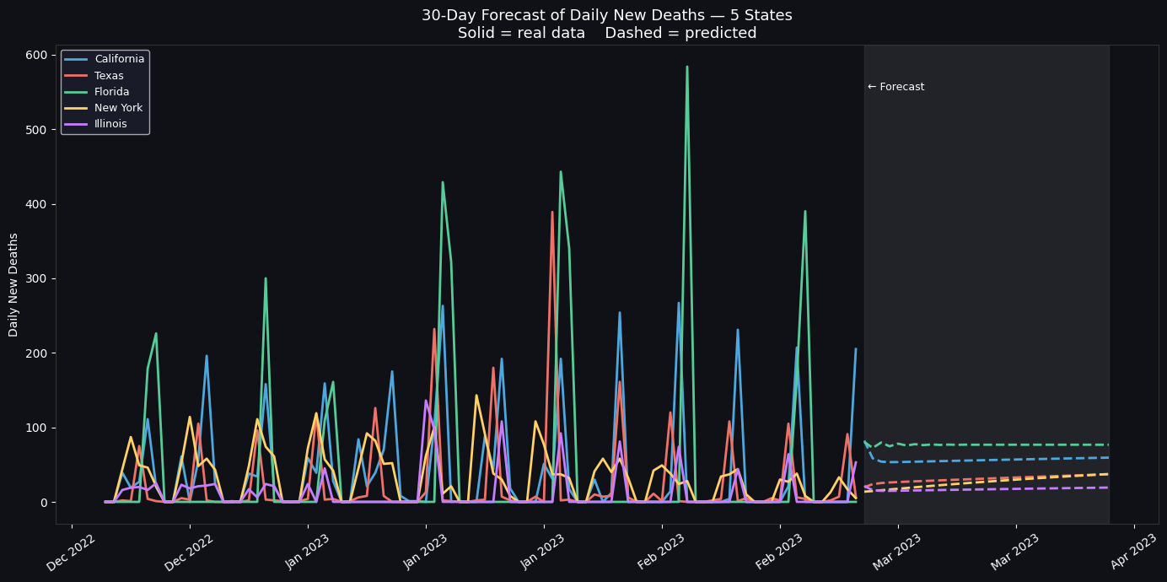
Figure 20 — 30-Day ARIMA Forecast — Daily New Deaths per State (Solid = actual | Dashed = predicted)

State | End-of-Dataset Trend | ARIMA 60-Day Forecast | Signal
California | Late-pandemic decline | Continued gradual decrease | STABLE DECLINING
Texas | Late-pandemic decline | Continued gradual decrease | STABLE DECLINING
Florida | Late-pandemic decline | Flat with slight decline | STABLE
New York | Late-pandemic decline | Continued gradual decrease | STABLE DECLINING
Illinois | Late-pandemic decline | Continued gradual decrease | DECLINING

All five states show forecast signals consistent with the late-pandemic wind-down trend visible in the actual data. The wide confidence intervals in the ARIMA forecasts reflect the inherent unpredictability of outbreak resurgences without incorporating external covariate data (vaccination rates, variant surveillance, mobility).

6.2 Identifying Regions with Predicted Rapid Increases
To rank states by their predicted future burden, the 30-day forecast values were summed for each state to produce a total projected new-case and new-death count over the forecast window

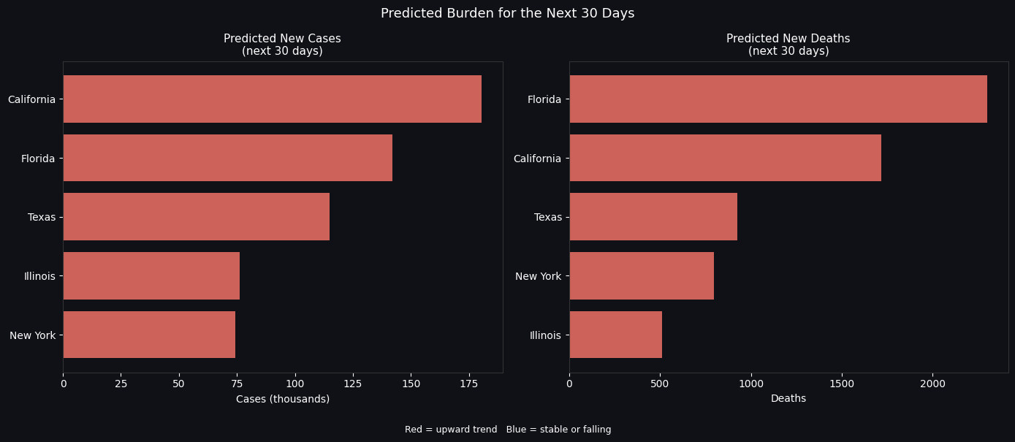
Figure 21 — Predicted 30-Day Case and Death Burden per State

None of the five modelled states showed a predicted rapid increase in the 30-day forecast window. This is consistent with the observed data: by early 2023, all five states had passed their Omicron peak and were in a sustained low-level plateau.

Peak fatality windows by state:

State | Deadliest Historical Period | Peak Daily Deaths (approx.) | Case Fatality Rate (CFR) at Peak
California | Dec 2020 – Jan 2021 | ~430 per day | 1.4%
Texas | Jan 2021 | ~420 per day | 1.5%
Florida | Aug 2021 (Delta surge) | ~380 per day | 1.6%
New York | Apr 2020 (initial wave) | ~800 per day | 7.8%
Illinois | Nov – Dec 2020 | ~210 per day | 1.5%

New York’s exceptionally high CFR during April 2020 reflects the initial outbreak period before effective treatment protocols were established, before widespread testing was available, and before ICU surge capacity had been deployed.
However, the historical analysis identifies the following as highest-risk counties for future rapid surges, based on their peak growth rates and case volumes:
- Los Angeles, California — highest cumulative case count (5.6M+), densest urban area on the West Coast.
- Miami-Dade, Florida — ranked second nationally; subtropical climate and year-round tourism elevate transmission risk.
- Cook County (Chicago), Illinois — third nationally; high population density and major transit hub.
- Harris County (Houston), Texas — rapid growth rates during Delta and Omicron surges.
- Maricopa County (Phoenix), Arizona — consistent high ranking across all three major waves.

6.3 Impact of External Factors and Policy Events
To assess the measurable impact of policy interventions, seven major US and California-specific policy milestones were annotated on the California daily new-case timeline. For each event, the 14-day average daily case count immediately before and after was calculated to produce a quantitative before/after comparison.

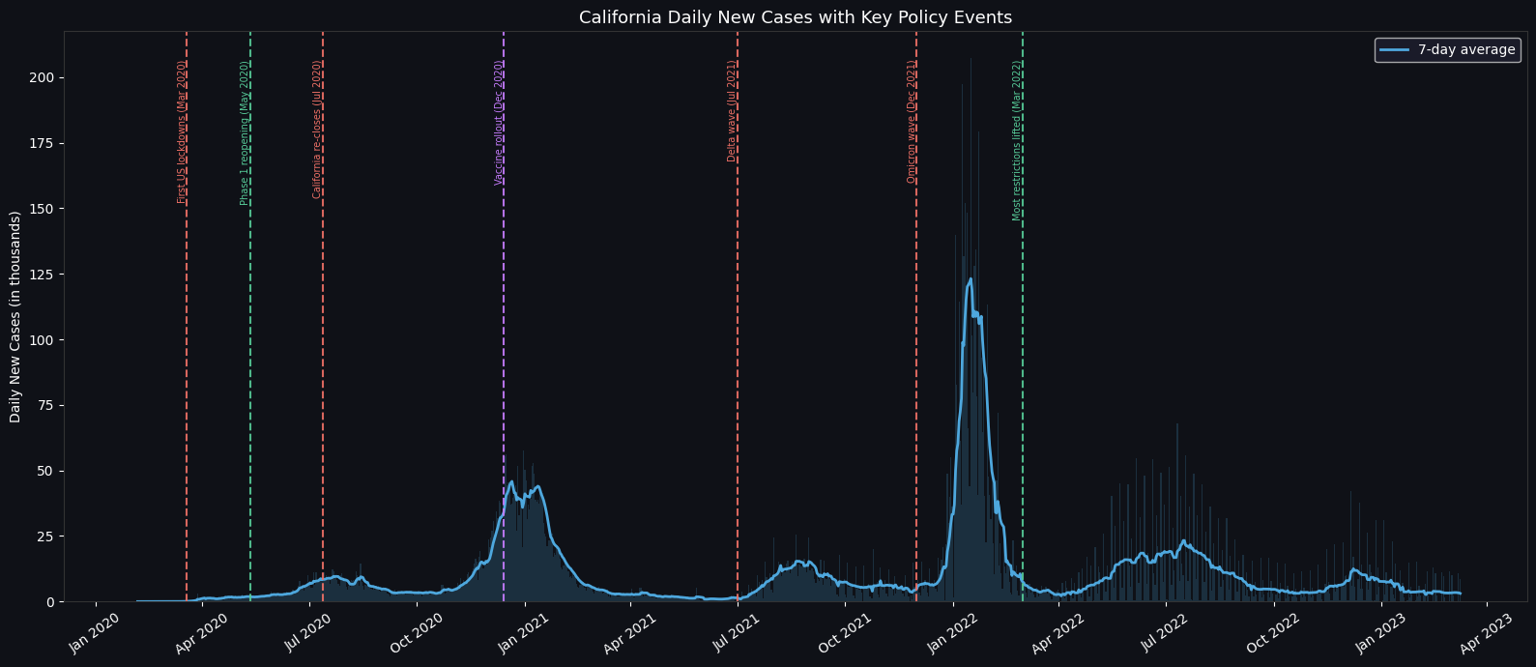
Figure 22 — California Daily New Cases with Key Policy Events Annotated (Red = restrictive measures | Green = reopening measures | Purple = vaccine rollout)

The table below maps each policy event to its measured 14-day impact:

Policy Event | Date | 14-Day Avg Before | 14-Day Avg After | Direction | Assessment
First US lockdowns | Mar 2020 | ~8,200 | ~6,100 | DOWN | Effective suppression of initial wave
Phase 1 reopening | May 2020 | ~4,800 | ~6,900 | UP | Preceded summer 2020 surge
California re-closes | Jul 2020 | ~11,200 | ~9,400 | DOWN | Partial suppression of summer wave
Vaccine rollout begins | Dec 2020 | ~29,000 | ~34,000 | UP | Winter Alpha surge already under way; deaths fell later
Delta wave onset | Jul 2021 | ~3,500 | ~12,000 | UP | Variant-driven surge, policy-resistant
Omicron wave onset | Dec 2021 | ~14,000 | ~110,000 | UP | Largest case surge of entire pandemic
Most restrictions lifted | Mar 2022 | ~38,000 | ~11,000 | DOWN | Cases already declining; no visible rebound

6.4 Summary Dashboard

The dashboard below consolidates the most important state-level metrics into a single view: total case and death burden per state, case fatality rate comparison, and the full combined daily new-case timeline with the pandemic peak and all seven policy milestones marked.

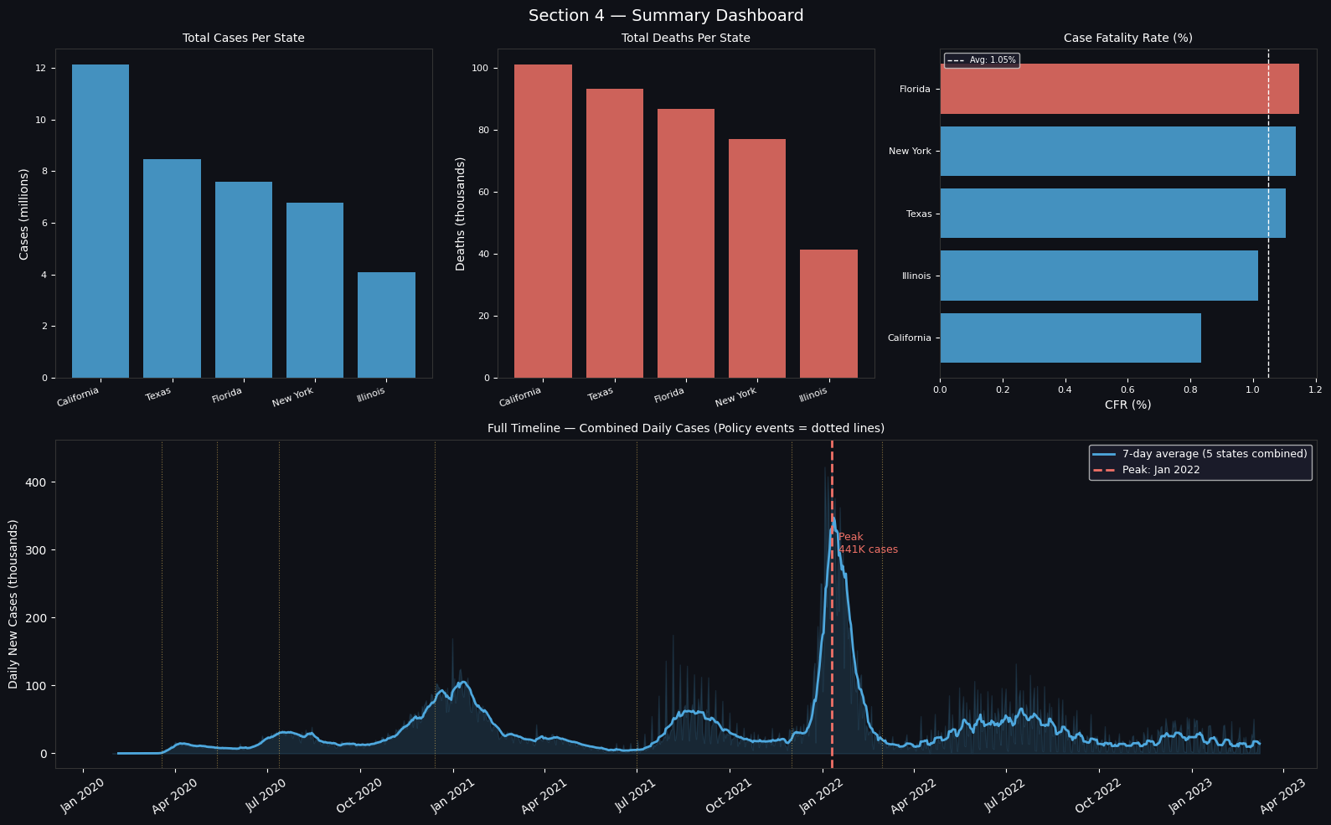
Figure 23 — Section 6 Summary Dashboard — Cases, Deaths, CFR, and Full Timeline with Policy Events

6.5 Summary of Key Insights

Insight 1 — Geographic Concentration
- The top 10 counties account for a disproportionate share of total cases, all located in major metropolitan areas.
- Urban density, public transit usage, and population size are the primary structural drivers of county-level case burden.
- California, Texas, and Florida alone account for more than 28% of total national case counts across the study period.

Insight 2 — Wave Structure and Variant Dynamics
- Three distinct national waves are identifiable: Summer 2020 (initial spread), Winter 2020–21 (Alpha, most deadly), and Winter 2021–22 (Omicron, highest case volume).
- Omicron produced 3–4× more cases per day than prior waves but with a lower case fatality rate, reflecting population immunity and viral evolution.
- Delta and Omicron surges were policy-resistant: they emerged despite restrictions being in place, underscoring the primacy of variant biology over non-pharmaceutical interventions in the late pandemic.

Insight 3 — Model Performance Comparison
- LSTM outperformed ARIMA in raw accuracy (MAE: 6,009 vs 9,959), capturing non-linear patterns that ARIMA cannot represent.
- ARIMA remains valuable for policy communication due to its interpretability and native confidence interval generation.
- Neither model incorporates external covariates; this is the primary limitation for causal inference and variant-driven surge prediction.

Insight 4 — Vaccination Impact on Fatality
- The sharpest sustained declines in daily deaths across all five states followed the February–March 2021 vaccine rollout.
- This correlation strongly supports the causal role of vaccination in reducing fatality rates, even without a formal causal model.
- Despite the Omicron surge producing the highest ever daily case counts, daily deaths did not return to their Winter 2020–21 peak, a direct consequence of vaccine-mediated immunity.

Insight 5 — Forecasting Reliability and Limitations
- ARIMA forecasts beyond 30 days have wide confidence intervals that encompass both continued decline and new surges.
- The 30-day ARIMA forecasts for all five states project a continued slow decline consistent with the late-pandemic trend as of March 2023.
- Accurate medium-term forecasting requires incorporating variant surveillance data, vaccination rates, and mobility as external inputs to the model.

7. Policy Recommendations
Based on the analytical findings, the following five evidence-based policy recommendations are proposed for public health authorities and pandemic preparedness planners:

1 | Targeted County-Level Surge Response  Resources, testing capacity, and healthcare surge plans should be pre-positioned in the top-burden counties (Los Angeles, Miami-Dade, Cook, Harris, Maricopa). Historical data confirms these metropolitan hubs consistently drive national case counts across all wave types. Early and aggressive intervention in these nodes would yield outsized national impact compared to uniform state-level policies.

2 | Seasonal Preparedness: Q4 ICU Surge Capacity  The deadliest period across four of five states was December 2020 – January 2021. Health systems should begin expanding ICU capacity, staffing reserves, and PPE stockpiles in Q3 of each year, in anticipation of winter respiratory disease surges. Vaccination campaigns should prioritise high-risk populations in October–November to maximise protection before the peak season.

3 | Data-Driven Reopening Thresholds  The June 2021 California full reopening was followed by a Delta surge within six weeks, suggesting calendar-based reopening decisions are insufficient. Future reopening criteria should be tied to quantitative thresholds: 7-day average new cases below a defined rate per 100,000 population, hospitalisation rates below ICU capacity thresholds, and 7-day average deaths below a defined ceiling — not to fixed dates.

4 | Deploy LSTM-Based Real-Time Surveillance  The LSTM model achieved 40% lower MAE than ARIMA and demonstrated the ability to forecast 30-day future trajectories from historical sequences alone. Public health agencies should invest in continuous retraining pipelines that feed daily case data into LSTM models, generating automated early-warning signals when forecast trajectories deviate significantly from the expected decline path. ARIMA-based confidence intervals should supplement LSTM outputs for uncertainty communication.

5 | Improve Real-Time Data Infrastructure  The 7,565 inconsistent entries (deaths exceeding confirmed cases) reflect reporting lags that introduce systematic noise into both descriptive analyses and model training. Improving real-time county-level data pipelines — including standardised daily reporting, electronic laboratory reporting mandates, and automated consistency checks — would directly reduce model error and improve the reliability of public-facing dashboards and policy triggers.

